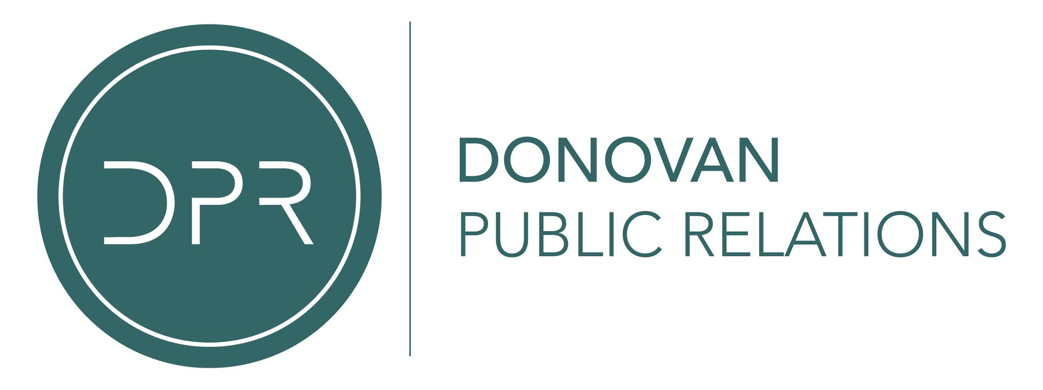

OLD DOMINION EXPAND “MAKE IT SWEET TOUR” THROUGH END OF THE YEAR

FEATURING SPECIAL GUESTS SCOTTY McCREERY & MICHAEL RAY

JORDAN DAVIS JOINS NEWLY ANNOUNCED INTERNATIONAL DATES

MORGAN EVANS, RYAN GRIFFIN & RYAN HURD
SET TO OPEN ON SELECT NEW DATES

RECENTLY RELEASED NEW SONG “SOME PEOPLE DO”

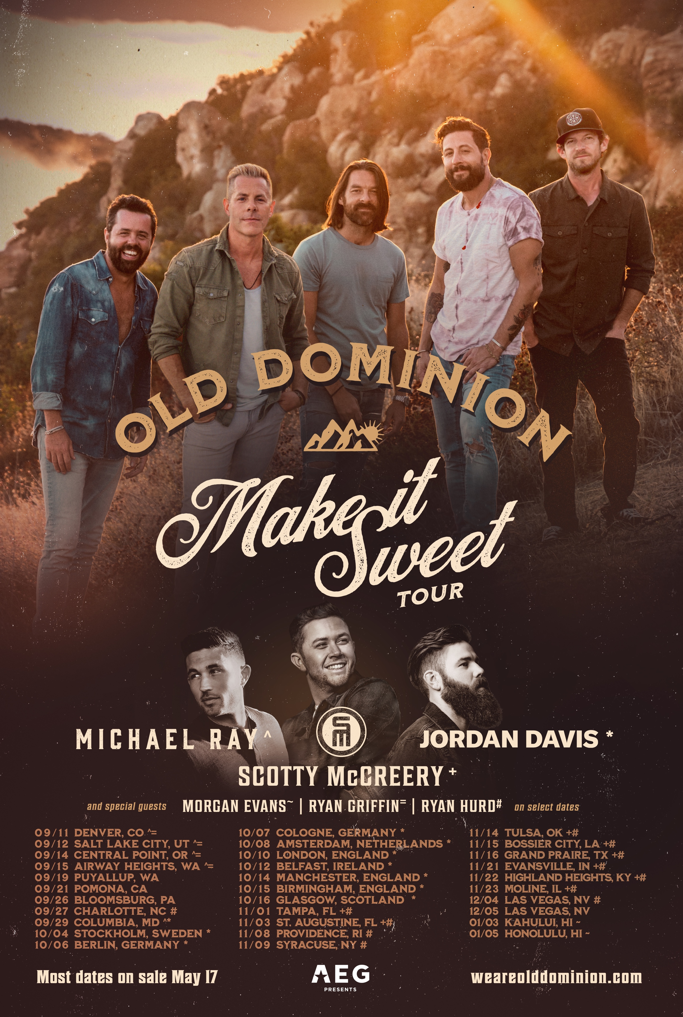

(Nashville, TN-May 9, 2019)—Acclaimed country band Old Dominion add new dates and cities to their “Make It Sweet Tour.” Expanding on an already stacked schedule, the AEG powered outing adds over 30 cities in six countries throughout the end of summer, fall and winter with big names as special guests as Scotty McCreery joins for 8 shows, Michael Ray for 5 and Jordan Davis added to the international run. Morgan Evans, Ryan Griffin and Ryan Hurd are set to open on select dates. See full routing below with new dates in bold and click HERE for more info!

Last week, Old Dominion released their deeply personal new song “Some People Do.” The soul baring track, which begs the listener for redemption and second chances, was released following the band’s current single “Make It Sweet” going #1 on the Billboard Country Airplay and Mediabase charts.

Old Dominion made their return to Nashville over the weekend with a sold-out performance at Ascend Amphitheater following their performance on the mainstage at Stagecoach Country Music Festival. Click HERE to watch their performance of “Make It Sweet” from the festival!

Last month, Old Dominion won “Group of the Year” at the 54th Annual ACM Awards at the MGM Grand Garden Arena in Las Vegas, NV. The award marks the band’s second consecutive win in this category and third ACM Award overall! Click HERE to view! Earlier this week, they were also nominated for “Group Video of the Year” at the upcoming 2019 CMT Music Awards.

“MAKE IT SWEET” TOUR DATES:
May 10 – Moncton, New Brunswick, Canada – Avenir Centre &%
May 12 – St. John’s, Newfoundland, Canada – Mile One Center &%
May 17 – New York, NY – Hulu Theatre at Madison Square Garden *@
May 18 – Philadelphia, PA – Skyline Stage @ The Mann *@
May 19—New York, NY—Webster Hall
May 23 – Portland, ME – Thompson’s Point *@
May 24 – Gilford, NH – Bank of New Hampshire Pavilion *@
May 25 – Farmingville, NY – Brookhaven Amphitheater *@
May 31 – Virginia Beach, VA – Patriotic Festival ~!
June 1 – Trenton, NJ – CURE Insurance Arena
June 8—Columbus, GA—2019 Denim and Diamonds
June 9—Nashville, TN—CMA Music Festival
June 13—Windsor, Canada—Caesars Windsor *
June 15 – Winsted, MN – Winstock Country Music Festival
June 16—Santa Rosa, CA—Country Summer Music Featival
June 21 – Manhattan, KS – Country Stampede
June 22—Camdenton, MO—Ozarks Amphitheater
June 28 – Dauphin, Canada – Dauphin's Countryfest
July 5—Avon, OH—Avon Hot Summer Nights Country Music Festival
July 6—Saratoga Springs, NY—Countryfest 2019
July 10 – London, Canada – Rock the Park Music Festival
July 12 – Rhinelander, WI – Hodag Country Festival
July 13—Chicago, IL—Windy City Smokeout
July 20—Brooklyn, MI—Faster Horses Festival
July 24—Murphys, CA—Ironstone Amphitheater
July 25—Paso Robles, CA—California Mid-State Fair
July 27 – Hillsboro, OR – Washington County Fair
Aug 1—Redmond, OR—Deschutes County Fair
Aug 3 – Camrose, Canada – Big Valley Jamboree
Aug 4 – Merritt, Canada – Rockin' River Music Festival
Aug 9—West Allis, WI—Wisconsin State Fair
Aug 11—Billings, MT—MontanaFair
Aug 15—Springfield, MO—Illinois State Fair
Aug 17—Thornville, OH—Country Jam and Campout
Aug 24—Morgantown, WV—Wild and Wonderful Country Fest
Sept 11—Denver, CO—Red Rocks Amphitheatre ^=
Sept 12—Salt Lake City, UT—Utah State Fair ^=
Sept 14— Central Point, OR—Southern Oregon Brew Fest ^=
Sept 15—Airway Heights, WA—Northern Quest Resort and Casino ^=
Sept 19—Puyallup, WA—Washington State Fair
Sept 21—Pomona, CA—LA County Fair
Sept 26— Bloomsburg, PA—Bloomsburg Fair
Sept 27—Charlotte, NC—Spectrum Center #
Sept 29—Columbia, MD— WPOC’S Sunday in The Country at Merriweather Post Pavilion^*
Oct 4—Stockholm, Sweden—Nalen *
Oct 6—Berlin, Germany—Astra Kulturhaus *
Oct 7—Cologne, Germany—Live Music Hall *
Oct 8—Amsterdam, Netherlands—Melkweg *
Oct 10—London, England—Hammersmith Apollo *
Oct 12—Belfast, Ireland—Waterfront Hall *
Oct 14—Manchester, England—Albert Hall *
Oct 15—Birmingham, England—O2 Academy Birmingham *
Oct 16—Glasgow, Scotland—O2 Academy Glasgow *
Nov 1—Tampa, FL—Yuengling Center +#
Nov 3—St. Augustine, FL—The Amp St.Augustine +#
Nov 8—Providence, RI—Dunkin' Donuts Center #
Nov 9—Syracuse, NY—The Oncenter War Memorial Arena #
Nov 14—Tulsa, OK—BOK Center +#
Nov 15—Bossier City, LA—CenturyLink Center +#
Nov 16—Grand Praire, TX—The Theatre at Grand Prairie KSCS Country Fest +#
Nov 21—Evansville, IN—Ford Center +#
Nov 22—Highland Heights, KY—BB&T Arena at Northern Kentucky University +#
Nov 23—Moline, IL—TaxSlayer Arena +#
Dec 4—Las Vegas, NV—The Joint #
Dec 5—Las Vegas, NV—The Joint =
Jan 3—Kahului, HI—Maui Arts & Cultural Center ~
Jan 5—Honolulu, HI—Blaisdell Center ~

+ Scotty McCreery
^ Michael Ray
* Jordan Davis
# Ryan Hurd
@ Mitchell Tenpenny
~ Morgan Evans
= Ryan Griffin
! Brandon Lay
& The Washboard Union
% Jason Benoit

About AEG Presents
AEG Presents is one of the largest live music companies in the world. The company is dedicated to all aspects of live contemporary music performances, including producing and promoting global and regional concert tours, music events and world-renowned festivals. AEG Presents operates in North America, Europe and Asia through 16 regional offices that support its tours which include such artists as Taylor Swift, Paul McCartney, Elton John, The Rolling Stones, Justin Bieber, BTS, Ed Sheeran, Katy Perry and Kenny Chesney; produce or support over 25 music festivals, including the iconic Coachella Valley Music & Arts Festival, Stagecoach, the New Orleans Jazz & Heritage Festival, Hangout Festival, Electric Forest, and Firefly; and owns, manages or books more than 80 clubs and theaters. AEG Presents produces and promotes more than 11,000 shows annually worldwide and conducts business under such globally renowned brands as AEG Presents, Goldenvoice, The Bowery Presents, Concerts West, Messina Touring Group, Marshall Arts LTD, Madison House Presents and PromoWest Productions.

About Scotty McCreery
McCreery has earned two back-to-back No. 1 hits from his current album Seasons Change, which debuted at No. 1 on the Billboard Country Album chart: the RIAA Platinum-certified “Five More Minutes” and the RIAA Gold-certified “This is It,” which stayed at the top of the charts for two weeks. He co-wrote all 11 songs on Seasons Change, including his new single “In Between” which is a highlight of his live show currently selling out venues across the nation. All four of his albums have debuted at No. 1 on a Billboard Albums chart, with current combined sales surpassing 3 million copies. He’s earned four Platinum and two Gold singles; won the 10th season of “American Idol” in 2011; was named the ACM New Artist of the Year in 2011; won the CMT Music Award for Breakthrough Video of the Year (“The Trouble with Girls”) in 2012; American Country Awards for New Artist of the Year in 2011 and Breakthrough Artist of the Year in 2013; BMI Awards for writing One of the Top 50 Country Songs of the Year twice (in 2015 for “See You Tonight” and in 2018 for “Five More Minutes”); a Carolina Beach Music Award for National Dance/Shag Song of the Year (“Barefootin’”) in 2018; and the NSAI Nashville Songwriter Award for One of the Top Ten Songs I Wish I’d Written (“Five More Minutes”) in 2018. The North Carolina native released his first book, Go Big or Go Home: The Journey Toward the Dream, in 2016. McCreery launched his recording career by making history in 2011 as both the first country artist and the youngest male artist of any genre to debut his first studio album, the Platinum-certified Clear as Day, at No. 1 on the all-genre Billboard Top 200 Albums chart. For more information and his current tour schedule, visit www.ScottyMcCreery.com.

FOLLOW OLD DOMINION
Website | iTunes | Spotify | Facebook | Twitter | Instagram

PRESS CONTACT
Old Dominion
Carleen Donovan carleen@donovanpublicrelations.com
Elisa Kupelian elisa@donovanpublicrelations.com

Sony Music Nashville
Wendy Pearl wendy.pearl@sonymusic.com

Jordan Davis
Ailie Birchfield ailie.birchfield@umusic.com

Michael Ray
Ebie McFarland ebie@ebmediapr.com

Scotty McCreery
Ebie McFarland ebie@ebmediapr.com
Scott Stem scott@triple8mgmt.com

